EMAIL
From | Mohammed Mahin Ibnay Mamun (Project Manager)
To | Doctor Tate (Client)
Subject | Upgrade and expand the surgery and improve efficiency by allowing patients to access services using a website and smartphone app.
Dear Doctor Tate,

I would like to start by thanking you for the opportunity. I am happy to report that, as the project manager, the project was completed on schedule. Unfortunately, we went over the budget by around £800 but I will explain why and how we can fix this in the most professional way possible. Although we could meet your deadline, we have created the system that was asked for would be able to:

- allow patients to book and manage appointments
- allow patients to order repeat prescriptions
- enable doctors to manage patient prescriptions including:
- checking repeat prescription orders before they sign them off
- sending the prescription electronically to a pharmacist of the patient’s choosing.
As you mentioned at the beginning of this project you believe the new system will:
- reduce record keeping errors
- improve the ease with which patients can book appointments
- reduce the number of missed appointments
- improve office efficiency
• allow the surgery to effectively manage an increase in patient number
• reduce the number of administration staff required
reduce costs allowing more money to be put back into local services.

Our team has developed a system that requests what you asked for as listed below:
• a relational database
• a custom smartphone app
• a custom website
• the installation of two new servers and software
• the installation of four new desktops
• the installation of two access terminals for patients
• the installation of network infrastructure.

I started of this task the day u assigned me as the project manager on the 7th February 2022, I made a start by creating a pid document which allowed me to see all the project aims, management control, deliverables, responsibilities, assumptions, constraints, and how potential risks which you kindly warned me about which would affect the overall work on this task. The benefit of creating the Pid document and distributing a copy to each member in the team allowed every to get an insight on what we are aiming for and what will stop us from it.

Also noted on my PID document is a communication plan. Management of staff and control over them was very helpful due to this. A few examples are:
- I will meet with the client weekly to inform how we are doing
- I will have meeting with network engineers to catch up on how there doing and if any issue has appeared
- Whole team will discuss weekly how we think were doing on this project and if we need to change anything.

I created a risk table which shows all the possible risks which can occur and the best way for us to act, bearing this can lack us on our deadline or even or budget. for example, some tasks may have a risk causing us to redo or test again which can take an extra day. Another example which Is highly likely is lack of equipment which we did encounter. if it is delivered late or not delivered, we will have to reorder it costing us both time and money. Unfortunately, this problem did occur and I have mentioned in details how we arose from it in the most sensible and efficient way possible.

After my PID document, I made another document called cost plan and resource list which I will also send to you. I found out how many functions it takes to complete the task from task brief which u shared with me and multiplied it by how many it needs for that employee to complete. Some employees took longer than others of a certain task. I then divided the amount by 7.5 to show the 7 and a half days of work which you also mention in the assignment brief. Then I got a day which I can use for my Gantt chart and show how long it will take to complete this task.

The estimated overall cost of this project set by you was £45,000, which will cover all necessary results. This amount is covering employee pay, such as project manager, senior software developers, junior software developers, senior network engineers, junior network engineers, and SQL Developer. The cost also covers materials including: the following:

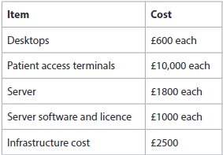
I used the table you so kindly provided to compare the costs of each task to the employees' salaries. By finding out how many hours the person needed to do the task, I was able to compute this. After figuring out their hours, I multiplied the total by the hourly rate.

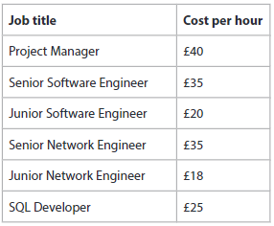

My document contains the results of all the calculations will show you how many hours and days each person is working and how much will receive. To examine each payment individually.

The project's overall cost was projected to be £45,000, but after I calculated the price of the essential supplies as well as pay, I learned that the real expense was just £ 45,835 (£835 over budget). I can see that the total cost of just the employees doing their tasks is £15,335. And the materials which u asked for came to £30,500 so when I get a total it went over by £835.

I then create a Gannt chart was to display the days that will be dedicated to each task. I had assigned a resource to each person which shows how much they will receive. For example :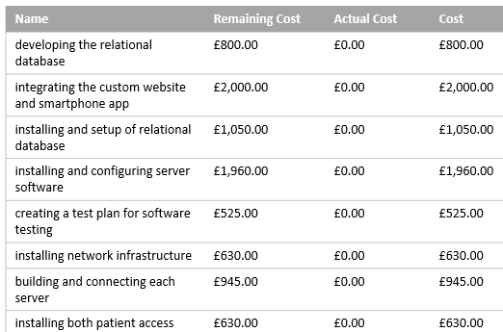

I was successful in overseeing the SQL Developer, senior network engineers, junior network engineers, senior software developers, and junior software developers. We completed the project by monitoring their performance on their assigned tasks and interacting with their subordinate staff.

I then created a checkpoint document which I hope you have also received which clearly shows how I have been checking up on the team and if there were any flaws that occurred during this task. There is a big section at the bottom of the paragraph which mentions in detail what each error was and who arose it and how we as a team took control of it.

I hope you have received all the documents and I hope you can appreciate my attempt at succeeding in this project. In order to cut down the budget we can’t drop any pays so we have to remove a material. You asked for 4 desktops if we dropped down to 1, we would be in budget but I don’t think 1 desktop will be enough. I think you should consider removing a server as we can manage on only 1. That way you won’t need 2 software licenses only 1 meaning u would save around £2000 - £3000. Please feel free to contact me again if you would like me to work for you again. My skills showed how I am a good project manager as I managed to correct all the issues before the deadline except for the budget. I also came to a conclusion on what the best solution would be for it.
Your sincerely: Mohammed Mahin Ibnay Mamun

